In [42]:

# package import
import psycopg2
import pandas as pd
import geopandas as gpd
from geopandas import GeoSeries, GeoDataFrame
import math
import numpy as np
import os
import time
import gc
import glob as gb
from tqdm import tqdm
from shapely import wkt
from shapely import geometry
from shapely.geometry import Polygon, Point , MultiPoint, LineString, MultiPolygon
from shapely.ops import unary_union
import matplotlib.pyplot as plt

In [12]:

#setting
import matplotlib.pyplot as plt
plt.rcParams['font.family'] = 'Malgun Gothic'

In [28]:

#read shape file
cty_shp=gpd.read_file('./data_raw/시도/ctprvn.shp', encoding='cp949')
cty_shp.head()

Out[28]:

 | CTPRVN_CD | CTP_ENG_NM | CTP_KOR_NM | geometry
0 | 11 | Seoul | 서울특별시 | POLYGON ((940286.568 1945875.197, 940267.507 1...
1 | 26 | Busan | 부산광역시 | MULTIPOLYGON (((1132664.9 1655415.815, 1132682...
2 | 27 | Daegu | 대구광역시 | POLYGON ((1090672.656 1766591.493, 1090673.465...
3 | 28 | Incheon | 인천광역시 | MULTIPOLYGON (((847834.755 1881816.658, 847840...
4 | 29 | Gwangju | 광주광역시 | POLYGON ((932712.687 1696168.692, 932781.68 16...

In [29]:

cty_shp.info()

<class 'geopandas.geodataframe.GeoDataFrame'>
RangeIndex: 17 entries, 0 to 16
Data columns (total 4 columns):
# Column Non-Null Count Dtype
--- ------ -------------- -----
0 CTPRVN_CD 17 non-null object
1 CTP_ENG_NM 17 non-null object
2 CTP_KOR_NM 17 non-null object
3 geometry 17 non-null geometry
dtypes: geometry(1), object(3)
memory usage: 676.0+ bytes

In [22]:

ax=cty_shp.plot()
plt.show()

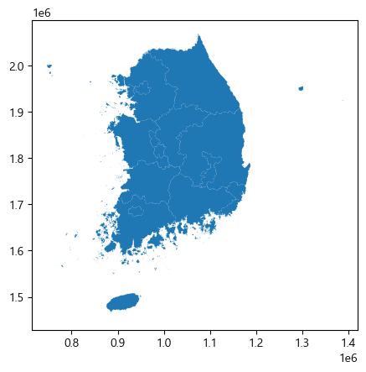

In [23]:

cty_shp.crs

Out[23]:

<Projected CRS: PROJCS["PCS_ITRF2000_TM",GEOGCS["ITRF2000",DATUM[" ...>
Name: PCS_ITRF2000_TM
Axis Info [cartesian]:
- [east]: Easting (metre)
- [north]: Northing (metre)
Area of Use:
- undefined
Coordinate Operation:
- name: unnamed
- method: Transverse Mercator
Datum: International Terrestrial Reference Frame 2000
- Ellipsoid: GRS 1980
- Prime Meridian: Greenwich

In [24]:

cty_shp.to_crs(epsg=5179)
cty_shp.crs

Out[24]:

<Projected CRS: PROJCS["PCS_ITRF2000_TM",GEOGCS["ITRF2000",DATUM[" ...>
Name: PCS_ITRF2000_TM
Axis Info [cartesian]:
- [east]: Easting (metre)
- [north]: Northing (metre)
Area of Use:
- undefined
Coordinate Operation:
- name: unnamed
- method: Transverse Mercator
Datum: International Terrestrial Reference Frame 2000
- Ellipsoid: GRS 1980
- Prime Meridian: Greenwich

In [ ]:

##### dst = 50000
#target_shp=cty_shp[] #시도 하나만 하도록!
#--------------- making bbox
# 몇개 셀로 나눠야할지 계산
x_cnt = int(np.ceil((cty_shp.unary_union.envelope.bounds[2]-cty_shp.unary_union.envelope.bounds[0])/dst))
y_cnt = int(np.ceil((cty_shp.unary_union.envelope.bounds[3]-cty_shp.unary_union.envelope.bounds[1])/dst))
print(x_cnt,y_cnt)

In [ ]:

#기준 지점 그리기
orign = [cty_shp.unary_union.envelope.bounds[0], cty_shp.unary_union.envelope.bounds[1]]
# grid cell 만들기
polygons = []
for xi in range(x_cnt):
for yj in range(y_cnt):
x1 = orign[0] + (dst * xi)
x2 = x1 + dst
y1 = orign[1] + (dst * yj)
y2 = y1 + dst
polygons.append(Polygon([(x1,y1), (x1,y2), (x2,y2), (x2,y1)]))
cty_grid = gpd.GeoDataFrame({'geometry' : polygons})

In [35]:

cty_grid.boundary.plot()
plt.show()

Out[35]:

<Axes: >

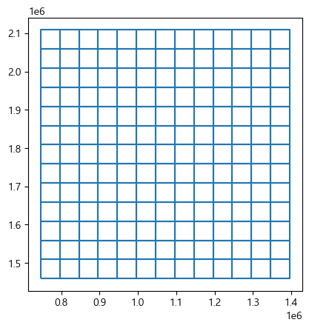

In [41]:

fig,ax = plt.subplots(1,1,sharex=True,sharey=True,figsize=(11,11))
cty_shp.plot(ax=ax)
cty_grid.boundary.plot(ax=ax,color='red')
plt.show()

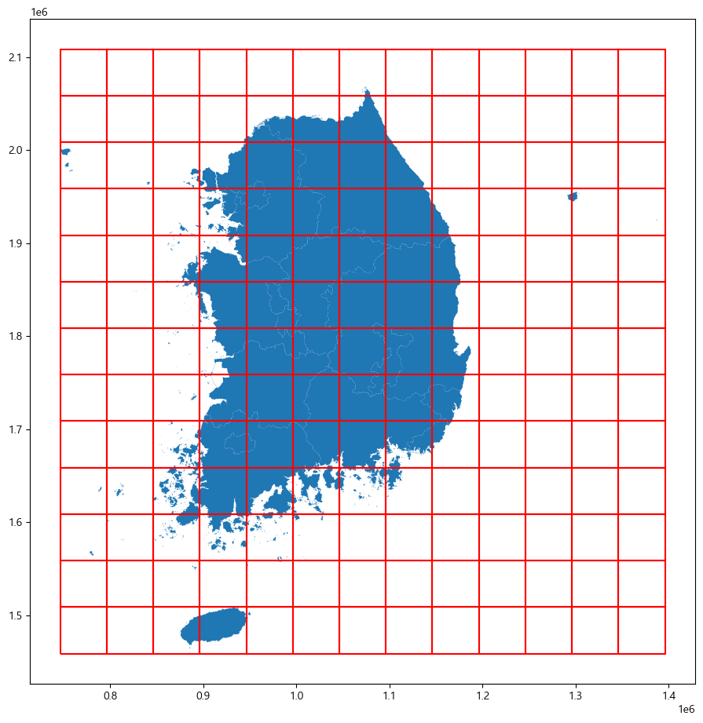

In [55]:

cty_grid

Out[55]:

 | geometry
0 | POLYGON ((746110.26 1458754.044, 746110.26 150...
1 | POLYGON ((746110.26 1508754.044, 746110.26 155...
2 | POLYGON ((746110.26 1558754.044, 746110.26 160...
3 | POLYGON ((746110.26 1608754.044, 746110.26 165...
4 | POLYGON ((746110.26 1658754.044, 746110.26 170...
... | ...
164 | POLYGON ((1346110.26 1858754.044, 1346110.26 1...
165 | POLYGON ((1346110.26 1908754.044, 1346110.26 1...
166 | POLYGON ((1346110.26 1958754.044, 1346110.26 2...
167 | POLYGON ((1346110.26 2008754.044, 1346110.26 2...
168 | POLYGON ((1346110.26 2058754.044, 1346110.26 2...
169 rows × 1 columns

In [65]:

#랜덤 숫자 넣기
cty_grid['cnt']=0
for n in cty_grid.index:
cty_grid.loc[n,'cnt'] = random.randrange(1,100)

In [66]:

cty_gridEPSG=4326

Out[66]:

 | geometry | cnt
0 | POLYGON ((746110.26 1458754.044, 746110.26 150... | 7
1 | POLYGON ((746110.26 1508754.044, 746110.26 155... | 70
2 | POLYGON ((746110.26 1558754.044, 746110.26 160... | 38
3 | POLYGON ((746110.26 1608754.044, 746110.26 165... | 78
4 | POLYGON ((746110.26 1658754.044, 746110.26 170... | 76
... | ... | ...
164 | POLYGON ((1346110.26 1858754.044, 1346110.26 1... | 48
165 | POLYGON ((1346110.26 1908754.044, 1346110.26 1... | 13
166 | POLYGON ((1346110.26 1958754.044, 1346110.26 2... | 98
167 | POLYGON ((1346110.26 2008754.044, 1346110.26 2... | 63
168 | POLYGON ((1346110.26 2058754.044, 1346110.26 2... | 33
169 rows × 2 columns

위경도 좌표계로 좌표변환¶

In [68]:

#epsg=5179(단위 좌표계)-> epsg=4326(위경도 좌표계)
cty_shp.to_crs(epsg=4326)

Out[68]:

 | CTPRVN_CD | CTP_ENG_NM | CTP_KOR_NM | geometry
0 | 11 | Seoul | 서울특별시 | POLYGON ((126.82434 37.51023, 126.82413 37.510...
1 | 26 | Busan | 부산광역시 | MULTIPOLYGON (((128.95175 34.88481, 128.95194 ...
2 | 27 | Daegu | 대구광역시 | POLYGON ((128.50466 35.89174, 128.50467 35.891...
3 | 28 | Incheon | 인천광역시 | MULTIPOLYGON (((125.79162 36.92244, 125.79169 ...
4 | 29 | Gwangju | 광주광역시 | POLYGON ((126.76029 35.2587, 126.76105 35.2585...
5 | 30 | Daejeon | 대전광역시 | POLYGON ((127.39892 36.4891, 127.40016 36.4879...
6 | 31 | Ulsan | 울산광역시 | MULTIPOLYGON (((129.34886 35.3741, 129.34886 3...
7 | 36 | Sejong-si | 세종특별자치시 | POLYGON ((127.17841 36.59687, 127.17839 36.596...
8 | 41 | Gyeonggi-do | 경기도 | MULTIPOLYGON (((126.73088 37.04639, 126.73141 ...
9 | 43 | Chungcheongbuk-do | 충청북도 | POLYGON ((127.98141 37.25688, 127.98188 37.256...
10 | 44 | Chungcheongnam-do | 충청남도 | MULTIPOLYGON (((125.96862 36.23497, 125.96765 ...
11 | 46 | Jellanam-do | 전라남도 | MULTIPOLYGON (((126.92181 33.98876, 126.92178 ...
12 | 47 | Gyeongsangbuk-do | 경상북도 | MULTIPOLYGON (((129.48696 35.7384, 129.487 35....
13 | 48 | Gyeongsangnam-do | 경상남도 | MULTIPOLYGON (((128.08435 34.50367, 128.08456 ...
14 | 50 | Jeju-do | 제주특별자치도 | MULTIPOLYGON (((126.26745 33.11373, 126.26737 ...
15 | 51 | Gangwon-do | 강원특별자치도 | MULTIPOLYGON (((129.34455 37.1713, 129.34456 3...
16 | 52 | Jeonbuk-do | 전북특별자치도 | MULTIPOLYGON (((126.4276 35.44847, 126.42764 3...

In [74]:

cty_grid=cty_grid.set_crs(epsg=5179)
cty_grid=cty_grid.to_crs(epsg=4326)

In [75]:

#파일 저장
pd.DataFrame(cty_grid).to_csv('./data_result/sample.csv')
#pd.DataFrame(cty_grid).to_excel('./data_result/sample.xlsx')

